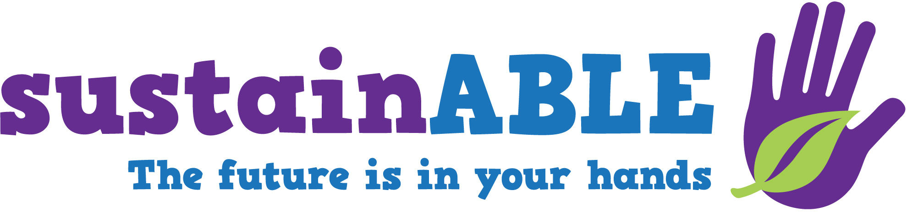
Your logo here

Date:
Contact:
Phone:
Email:

Learn about sustainability at [name of your organization]!
[Insert your local event location, dates, and specific activity information here].
The [name of your event] event at [name of your organization] is part of a nationwide effort to engage the public in sustainability and understand the social, environmental, and economic impact of human behavior on the planet’s future.
This event provides fun, hands-on opportunities to learn about sustainable solutions to many of our planet’s biggest challenges. Guests can roll marbles to decide how to share “water” resources, try to build sustainable “cities” out of blocks, discover the surprising materials that are used to create green products, and more!
[insert specific information about events or other special activities that your location may host].
[Some of] The activities offered at the event were developed as a collaboration of the Walton Sustainability Solutions Initiatives at Arizona State University® (ASU), the Center for Engagement and Training in Science & Society at ASU, Science Museum of Minnesota, and Ithaca Sciencenter. The development work was supported by the Walton Sustainability Solutions Initiatives at ASU. The educational materials were distributed to science centers and museums by the National Informal STEM Education Network.

