UOEEE – CoursEval Report Access Guide

Reports are available through the CoursEval Participant Portal.

The easiest path get to the portal is through MyASU.
- On the Faculty/Staff tab...
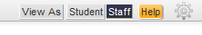

- Look for ‘Teaching & Student Support Tools’. A link for ‘Course Evaluations’ is at the bottom.

Participant Portal
- Since you are already logged into MyASU you should automatically be taken into the portal. Once there you will be looking for the Reports link. Select the ‘Reports’ button.

Accessing past reports
- If you already have courses showing below My Reports, you may pull up a specific course report from that page by selecting ‘View Report’. To be able to select from current and past reports, select ‘All Reports’
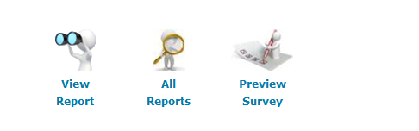

- If you don’t have any specific courses showing under reports, click ‘Here’ to see past reports.
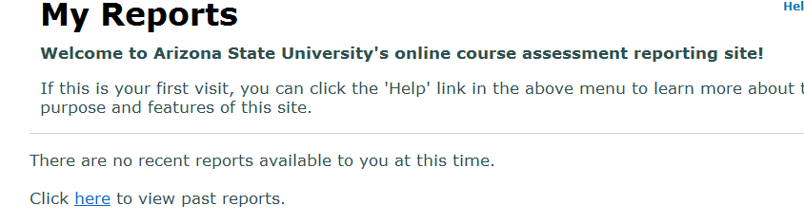

Filtering Reports
- The next page is where you can filter for reports for specific courses. The most important thing is to be sure that the filters at the top are set for ‘Show All’ and are clear. That way you begin with all your available reports. From there, you can use the filters to narrow down for specific semesters or periods. Period codes use the following logic. The middle digits of the period code denote the year and the last digit marks the term 1=Spring, 4=Summer, and 7=Fall. So 2127 has 12 for 2012 and a 7 for fall, Fall 2012.

- Below the filters, you will see all of your available reports. Use the check boxes on the right and under ‘Include’ to select which report you would like to see. Above ‘Include’, ‘View Report’ creates a new browser window where your selected report will be available.

